Lecture One :INTRODUCTION
This chapter provides an introduction to Computer networks and covers fundamental topics like data, information to the definition of communication and computer networks.
The main objective of data communication and networking is to enable seamless exchange of data between any two points in the world.
This exchange of data takes place over a computer network.

1.2 DATA & INFORMATION
Data refers to the raw facts that are collected while information refers to processed data that enables us to take decisions.
Ex. When result of a particular test is declared it contains data of all students, when you find the marks you have scored you have the information that lets you know whether you have passed or failed.
The word data refers to any information which is presented in a form that is agreed and accepted upon by is creators and users.

1.3 DATA COMMUNICATION
Data Communication is a process of exchanging data or information
In case of computer networks this exchange is done between two devices over a transmission medium.
This process involves a communication system which is made up of hardware and software. The hardware part involves the sender and receiver devices and the intermediate devices through which the data passes. The software part involves certain rules which specify what is to be communicated, how it is to be communicated and when. It is also called as a Protocol.
The following sections describes the fundamental characteristics that are important for the effective working of data communication process and is followed by the components that make up a data communications system.

1.3.1 Characteristics of Data Communication
The effectiveness of any data communications system depends upon the following four fundamental characteristics:
1. Delivery: The data should be delivered to the correct destination and correct user.
2. Accuracy: The communication system should deliver the data accurately, without introducing any errors. The data may get corrupted during transmission affecting the accuracy of the delivered data.
3. Timeliness: Audio and Video data has to be delivered in a timely manner without any delay; such a data delivery is called real time transmission of data.
4. Jitter: It is the variation in the packet arrival time. Uneven Jitter may affect the timeliness of data being transmitted.

1.3.2 Components of Data Communication A Data Communication system has five components as shown in the diagram below:
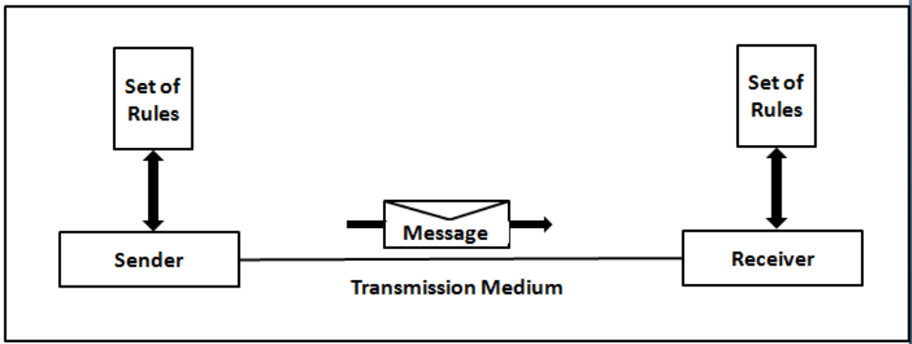

Fig. Components of a Data Communication System
1. Message Message is the information to be communicated by the sender to the receiver.
2. Sender
The sender is any device that is capable of sending the data (message).
3. Receiver
The receiver is a device that the sender wants to communicate the data (message).
4. Transmission Medium
It is the path by which the message travels from sender to receiver. It can be wired or wireless and many subtypes in both. 4
5. Protocol
It is an agreed upon set or rules used by the sender and receiver to communicate data.
A protocol is a set of rules that governs data communication.
A Protocol is a necessity in data communications without which the communicating entities are like two persons trying to talk to each other in a different language without know the other language.

1.4 DATA REPRESENTATION
Data is collection of raw facts which is processed to deduce information. There may be different forms in which data may be represented. Some of the forms of data used in communications are as follows:
1. Text
Text includes combination of alphabets in small case as well as upper case.
It is stored as a pattern of bits. Prevalent encoding system : ASCII, Unicode

2. Numbers
Numbers include combination of digits from 0 to 9.
It is stored as a pattern of bits. Prevalent encoding system : ASCII, Unicode

3. Images
―An image is worth a thousand words‖ is a very famous saying. In computers images are digitally stored.

A Pixel is the smallest element of an image. To put it in simple terms, a picture or image is a matrix of pixel elements.

The pixels are represented in the form of bits. Depending upon the type of image (black n white or color) each pixel would require different number of bits to represent the value of a pixel.

The size of an image depends upon the number of pixels (also called resolution) and the bit pattern used to indicate the value of each pixel.

Example: if an image is purely black and white (two color) each pixel can be represented by a value either 0 or 1, so an image made up of 10 x 10 pixel elements would require only 100 bits in memory to be stored.
On the other hand an image that includes gray may require 2 bits to represent every pixel value (00 - black, 01 – dark gray, 10 – light gray, 11 –white). So the same 10 x 10 pixel image would now require 200 bits of memory to be stored.

Commonly used Image formats : jpg, png, bmp, etc

4. Audio
Data can also be in the form of sound which can be recorded and broadcasted. Example: What we hear on the radio is a source of data or information.
Audio data is continuous, not discrete.

5. Video
Video refers to broadcasting of data in form of picture or movie

1.5 DATA FLOW- Two devices communicate with each other by sending and receiving data. The data can flow between the two devices in the following ways.
1. Simplex
2. Half Duplex
3. Full Duplex
1.5.1 Simplex

Figure: Simplex mode of communication
In Simplex, communication is unidirectional
Only one of the devices sends the data and the other one only receives the data.
Example: in the above diagram: a cpu send data while a monitor only receives data.

1.5.2 Half Duplex

Figure: Half Duplex Mode of Communication
In half duplex both the stations can transmit as well as receive but not at the same time.
When one device is sending other can only receive and vice-versa (as shown in figure above.)
Example: A walkie-talkie.

1.5.3 Full Duplex
Figure: Full Duplex Mode of Communication
In Full duplex mode, both stations can transmit and receive at the same time.
Example: mobile phones

1.6 COMPUTER NETWORK
Computer Networks are used for data communications

Definition:

A computer network can be defined as a collection of nodes. A node can be any device capable of transmitting or receiving data. The communicating nodes have to be connected by communication links.
A Compute network should ensure
reliability of the data communication process, should c
security of the data
performance by achieving higher throughput and smaller delay times

1.6.1 Categories of Network
Networks are categorized on the basis of their size. The three basic categories of computer networks are:
A. Local Area Networks (LAN) is usually limited to a few kilometers of area. It may be privately owned and could be a network inside an office on one of the floor of a building or a LAN could be a network consisting of the computers in a entire building.

B. Wide Area Network (WAN) is made of all the networks in a (geographically) large area. The network in the entire state of Maharashtra could be a WAN

C. Metropolitan Area Network (MAN) is of size between LAN & WAN. It is larger than LAN but smaller than WAN. It may comprise the entire network in a city like Mumbai.

1.7 PROTOCOL
A Protocol is one of the components of a data communications system. Without protocol communication cannot occur. The sending device cannot just send the data and expect the receiving device to receive and further interpret it correctly.

When the sender sends a message it may consist of text, number, images, etc. which are converted into bits and grouped into blocks to be transmitted and often certain additional information called control information is also added to help the receiver interpret the data.

For successful communication to occur, the sender and receiver must agree upon certain rules called protocol.

A Protocol is defined as a set of rules that governs data communications.

A protocol defines what is to be communicated, how it is to be communicated and when it is to be communicated.

1.7.1 Elements of a Protocol
There are three key elements of a protocol:

A. Syntax
It means the structure or format of the data.
It is the arrangement of data in a particular order.

B. Semantics
It tells the meaning of each section of bits and indicates the interpretation of each section.
It also tells what action/decision is to be taken based on the interpretation.

C. Timing
It tells the sender about the readiness of the receiver to receive the data
It tells the sender at what rate the data should be sent to the receiver to avoid overwhelming the receiver.

1.7 STANDARDS IN NETWORKING
Standards are necessary in networking to ensure interconnectivity and interoperability between various networking hardware and software components.

Without standards we would have proprietary products creating isolated islands of users which cannot interconnect.

1.7.1 Concept of Standard
Standards provide guidelines to product manufacturers and vendors to ensure national and international interconnectivity.

Data communications standards are classified into two categories:

1. De facto Standard
o These are the standards that have been traditionally used and mean by fact or by convention
o These standards are not approved by any organized body but are adopted by widespread use.

2. De jure standard
o It means by law or by regulation.
o These standards are legislated and approved by an body that is officially recognized.

1.7.2 Standard Organizations in field of Networking

o Standards are created by standards creation committees, forums, and government regulatory agencies.

o Examples of Standard Creation Committees :

1. International Organization for Standardization(ISO) 2. International Telecommunications Union – Telecommunications Standard (ITU-T) 3. American National Standards Institute (ANSI) 4. Institute of Electrical & Electronics Engineers (IEEE) 5. Electronic Industries Associates (EIA)
o Examples of Forums

1. ATM Forum 2. MPLS Forum 3. Frame Relay Forum
o Examples of Regulatory Agencies:

1. Federal Communications Committee (FCC)
1.8 REVIEW QUESTIONS
1. Differentiate between data & information. What are the different forms in which data can be represented?
2. What are the characteristics of data communication?
3. What are the components of a data communication system?
4. Define computer network and categorize.
5. Explain protocols in details

